INDIVIDUAL PLACEMENT AND SUPPORT IS AN EVIDENCE-BASED PRACTICE FOR HELPING PEOPLE WITH SERIOUS MENTAL ILLNESS GAIN COMPETITIVE EMPLOYMENT.
Studies show 60%
of people with SMI want to work, but
only about 15%
are employed.
People living with serious mental illness want to work. IPS helps them attain their goals.

Beneﬁts of Work for People with Serious Mental Illness
- Increased self-esteem
- Better control of psychiatric symptoms
- Reduced psychiatric hospitalizations
- Reduced criminal justice involvement
- Increased self-suﬃciency
- Decreased dependence on others
A 10-year follow-up study of people with co-occurring serious mental illness and substance use disorder found an average annual savings of more than $16,000 per person in treatment costs for steady workers, compared to clients who remained out of the labor force.
HAVING A JOB CAN REDUCE THE COSTS OF REHABILITATION AND MENTAL HEALTH SERVICES.

EMPLOYMENT RATES: IPS VS. OTHER SERVICES

For every 100 people who enroll in IPS in the US, 60 get a job, more than twice as many as those who enroll in any other employment program.

60%

26%

THE IPS MODEL IS COST-EFFECTIVE

IPS in Tennessee is provided in partnership with the Department of Human Services - Vocational Rehabilitation and our network of community providers.
Community Providers
Tennessee
Counties

People Served in FY20
1,118

14

57%

Successful Placements Worked
90 Days or More

55

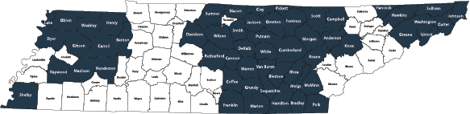

For More Information TDMHSAS Website: TN.gov/behavioral-health/ips
Contact:
Mark Liverman, Ed.S. Director of Wellness and Employment Mark.Liverman@tn.gov 615-253-6748
*Claims in this document are supported by more than two decades of research.
Visit IPSworks.org to learn more.

- IPS greatly outperforms standard employment supports.
- IPS works in both urban and rural communities. IPS works for youth and young adults.
- IPS works for people from diﬀerent racial, ethnic, and minority backgrounds.
- IPS supports people with education goals.
U.S. and International Randomized, Controlled Trials Show:
THE IPS MODEL IS EVIDENCE-BASED

